LAB PROGRAM CHAPTER 2
- Write a program to perform the following
  - An empty list
  - A list with one element
  - A list with all identical elements
  - A list with negative numbers Test Cases:
- Input: []
  - Expected Output: []
- Input: [1]
  - Expected Output: [1]
- Input: [7, 7, 7, 7]
  - Expected Output: [7, 7, 7, 7]
- Input: [-5, -1, -3, -2, -4]
o Expected Output: [-5, -4, -3, -2, -1]

CODE:
def sort_list(lst): return sorted(lst)
lists = [ [],
[1],
[7, 7, 7, 7],
[-5, -1, -3, -2, -4]
]
for l in lists: print("Input :", l)
print("Output:", sort_list(l)) print()

OUTPUT
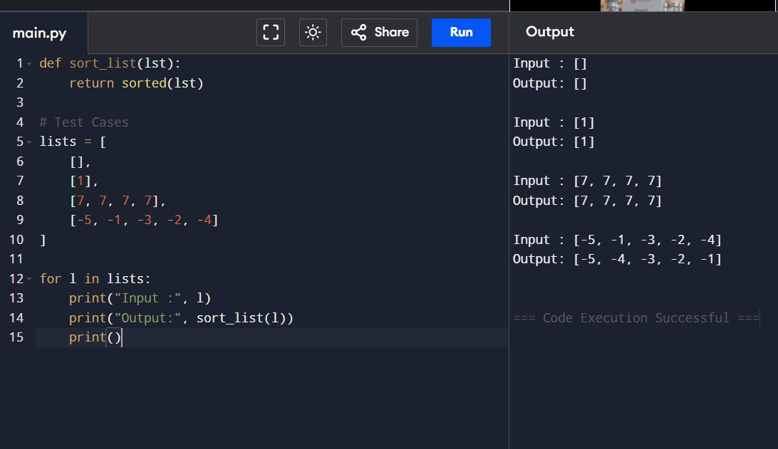
- Describe the Selection Sort algorithm&#39;s process of sorting an array. Selection Sort works by dividing the array into a sorted and an unsorted region. Initially, the sorted region is
empty, and the unsorted region contains all elements. The algorithm repeatedly selects the smallest element from the unsorted region and swaps it with the leftmost unsorted element, then moves the boundary of the sorted region one element to the right. Explain why Selection Sort is simple to understand and implement but is inefficient for large datasets. Provide examples to illustrate step-by-step how Selection Sort rearranges the
elements into ascending order, ensuring clarity in your explanation of the algorithm&#39;s mechanics and effectiveness.
Sorting a Random Array: Input: [5, 2, 9, 1, 5, 6]
Output: [1, 2, 5, 5, 6, 9]
Sorting a Reverse Sorted Array: Input: [10, 8, 6, 4, 2]
Output: [2, 4, 6, 8, 10]
Sorting an Already Sorted Array: Input: [1, 2, 3, 4, 5]

CODE
def selection_sort(arr): n = len(arr)
for i in range(n): min_index = i
for j in range(i + 1, n):
if arr[j] < arr[min_index]: min_index = j
arr[i], arr[min_index] = arr[min_index], arr[i] return arr
print(selection_sort([5, 2, 9, 1, 5, 6]))
print(selection_sort([10, 8, 6, 4, 2]))
print(selection_sort([1, 2, 3, 4, 5]))

OUTPUT
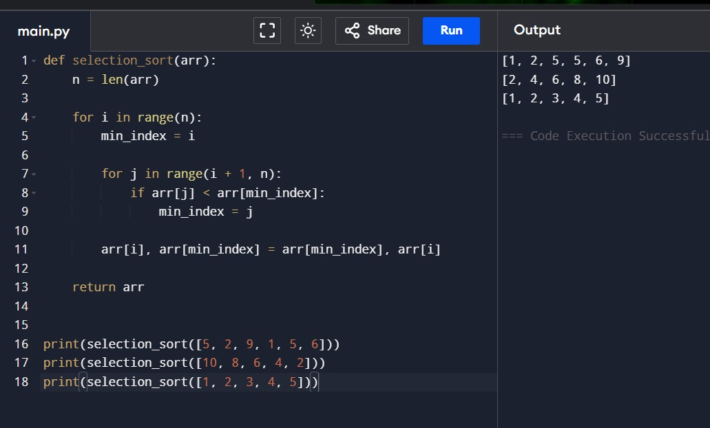

- Write code to modify bubble_sort function to stop early if the list becomes sorted before all passes are completed.

CODE
def bubble_sort(arr): n = len(arr)

for i in range(n): swapped = False
for j in range(0, n - i - 1): if arr[j] > arr[j + 1]:
arr[j], arr[j + 1] = arr[j + 1], arr[j] swapped = True
if not swapped: break
return arr print(bubble_sort([64,25,12,22,11])) print(bubble_sort([29,10,14,37,13])) print(bubble_sort([3,5,2,1,4]))
print(bubble_sort([1,2,3,4,5]))
print(bubble_sort([5,4,3,2,1]))

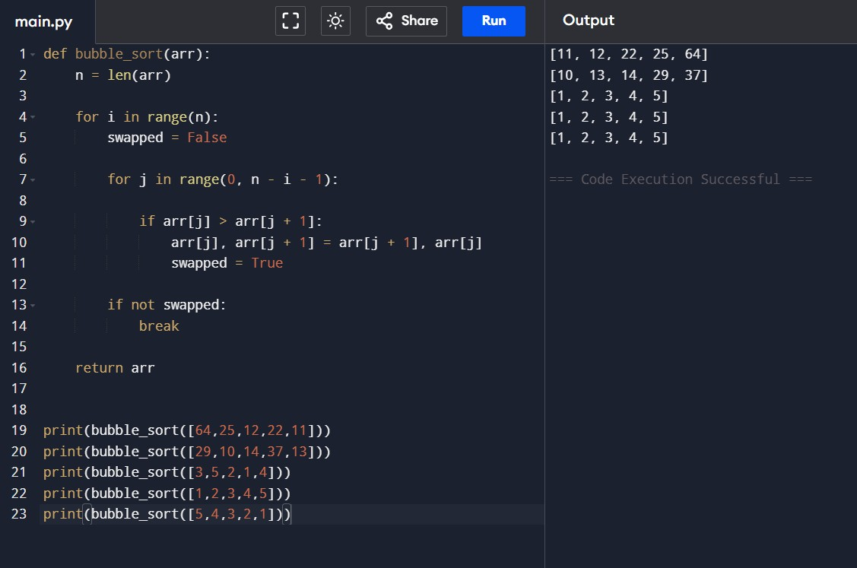
OUTPUT

- Write code for Insertion Sort that manages arrays with duplicate elements during
the sorting process. Ensure the algorithm&#39;s behavior when encountering duplicate values, including whether it preserves the relative order of duplicates and how it
affects the overall sorting outcome. CODE
def insertion_sort(arr):
for i in range(1, len(arr)): key = arr[i]
j = i - 1
while j >= 0 and arr[j] > key: arr[j + 1] = arr[j]
j -= 1
arr[j + 1] = key return arr
print(insertion_sort([3,1,4,1,5,9,2,6,5,3])) print(insertion_sort([5,5,5,5,5])) print(insertion_sort([2,3,1,3,2,1,1,3])) OUTPUT
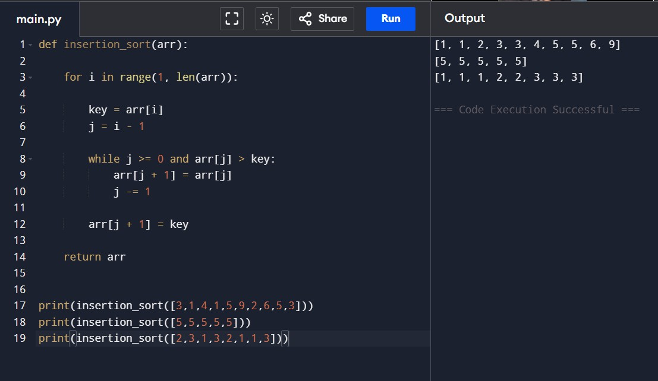

- Given an array arr of positive integers sorted in a strictly increasing order, and an integer k. return the kth positive integer that is missing from this array.
Example 1:
Input: arr = [2,3,4,7,11], k = 5 Output: 9
Explanation: The missing positive integers are [1,5,6,8,9,10,12,13,...]. The 5th missing positive integer is 9.
Example 2:
Input: arr = [1,2,3,4], k = 2 Output: 6
Explanation: The missing positive integers are [5,6,7,...]. The 2nd missing positive integer is 6.

CODE
def findKthPositive(arr, k): current = 1
i = 0
while k > 0:
if i < len(arr) and arr[i] == current: i += 1
else:
k -= 1
if k == 0:
return current current += 1
print(findKthPositive([2,3,4,7,11],5)) print(findKthPositive([1,2,3,4],2))

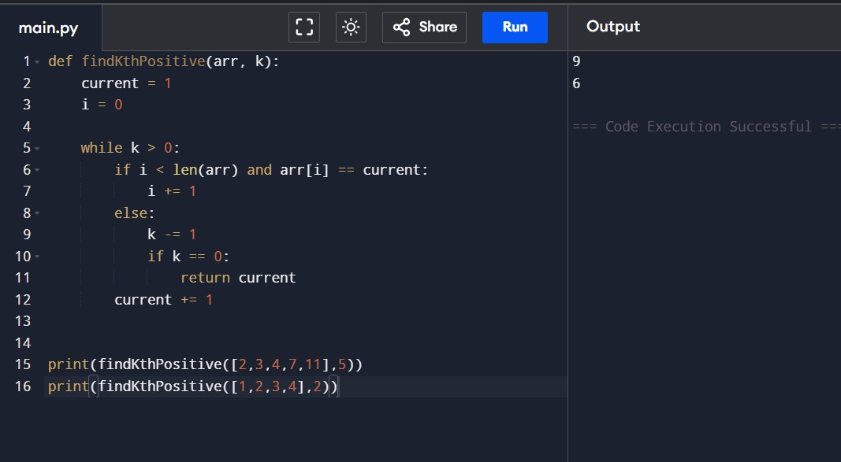
OUTPUT
- A peak element is an element that is strictly greater than its neighbors. Given a 0-indexed integer
array nums, find a peak element, and return its index. If the array contains multiple peaks, return the index to any of the peaks. You may imagine that nums[-1] = nums[n] = -∞. In other words, an element is always considered to be strictly greater than a neighbor that is outside the array. You must write an algorithm that runs in O(log n) time.

CODE
def findPeakElement(nums): left = 0
right = len(nums)-1 while left < right:
mid = (left+right)//2
if nums[mid] > nums[mid+1]: right = mid
else:
left = mid+1 return left
print(findPeakElement([1,2,3,1])) print(findPeakElement([1,2,1,3,5,6,4]))

OUTPUT
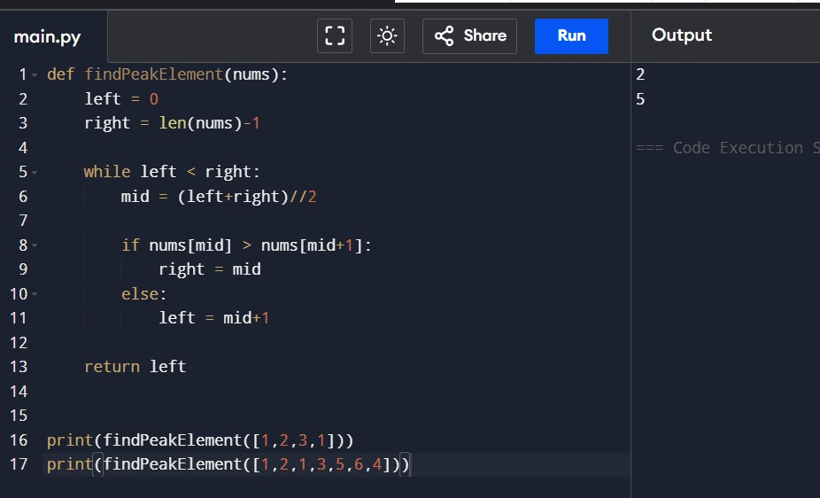

- Given two strings needle and haystack, return the index of the first occurrence of needle in haystack, or -1 if needle is not part of haystack.

CODE
def strStr(haystack, needle): return haystack.find(needle)
print(strStr("sadbutsad","sad")) print(strStr("leetcode","leeto"))’ OUTPUT
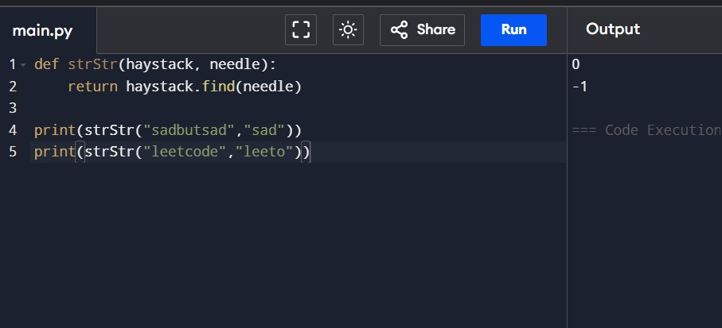

- Given an array of string words, return all strings in words that is a substring of another word. You can return the answer in any order. A substring is a contiguous sequence of characters within a string

CODE
def stringMatching(words): ans=[]
for i in range(len(words)): for j in range(len(words)):
if i!=j and words[i] in words[j]: ans.append(words[i])
break return ans
print(stringMatching(["mass","as","hero","superhero"])) print(stringMatching(["leetcode","et","code"])) print(stringMatching(["blue","green","bu"]))

OUTPUT
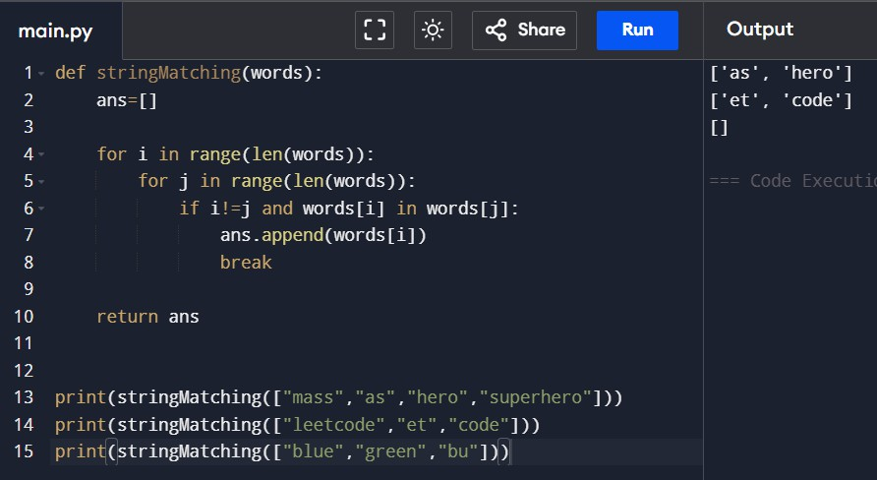

- Write a program that finds the closest pair of points in a set of 2D points using the brute force approach.

CODE
import math

def closest_pair(points): min_distance=float('inf') pair=None
for i in range(len(points)):
for j in range(i+1,len(points)): d=math.dist(points[i],points[j]) if d<min_distance:
min_distance=d pair=(points[i],points[j])
return pair,min_distance points=[(1,2),(4,5),(7,8),(3,1)]
pair,distance=closest_pair(points) print("Closest Pair:",pair) print("Minimum Distance:",distance) OUTPUT
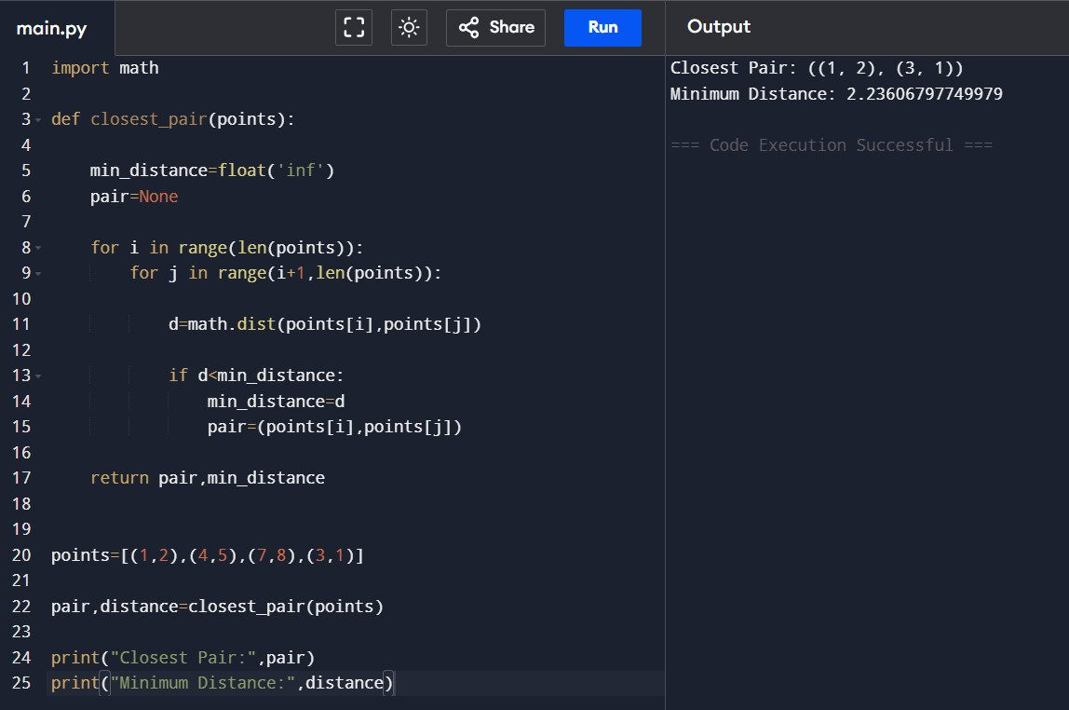

- Write a program to find the closest pair of points in a given set using the brute force approach. Analyze the time complexity of your implementation. Define a function to calculate the Euclidean distance between two points. Implement a function to find the closest pair of points using the brute force method. Test your program with a sample set of points and verify the correctness of your results. Analyze the time complexity of your implementation. Write a brute-force algorithm to solve the convex hull problem for the following set S of points? P1 (10,0)P2 (11,5)P3 (5, 3)P4 (9, 3.5)P5 (15, 3)P6 (12.5, 7)P7
(6, 6.5)P8 (7.5, 4.5).How do you modify your brute force algorithm to handle multiple points that are lying on the sameline?

CODE
def orientation(p,q,r):
return (q[0]-p[0])*(r[1]-p[1])-(q[1]-p[1])*(r[0]-p[0]) def convexHull(points):
n=len(points) if n<3:
return points hull=[] left=min(points) p=left
while True: hull.append(p) q=points[0]

for r in points:
if q==p or orientation(p,q,r)<0: q=r
p=q
if p==left: break
return hull points=[(10,0),(11,5),(5,3),(9,3.5),(15,3),(12.5,7),(6,6.5),(7.5,4.5)]
print(convexHull(points))

OUTPUT

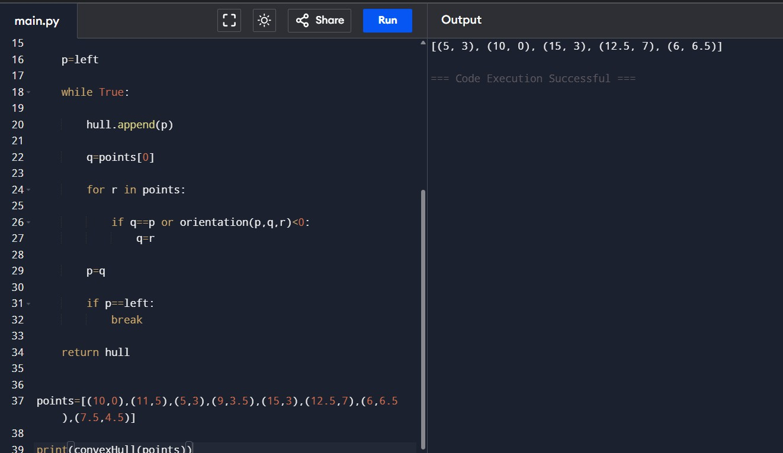
- Write a program that finds the convex hull of a set of 2D points using the brute force approach.

CODE
def orientation(p,q,r):
return (q[0]-p[0])*(r[1]-p[1])-(q[1]-p[1])*(r[0]-p[0]) def convexHull(points):
left=min(points) hull=[]
p=left while True:
hull.append(p) q=points[0] for r in points:
if q==p or orientation(p,q,r)<0: q=r
p=q
if p==left: break

return hull points=[(1,1),(4,6),(8,1),(0,0),(3,3)]

print(convexHull(points))

OUTPUT
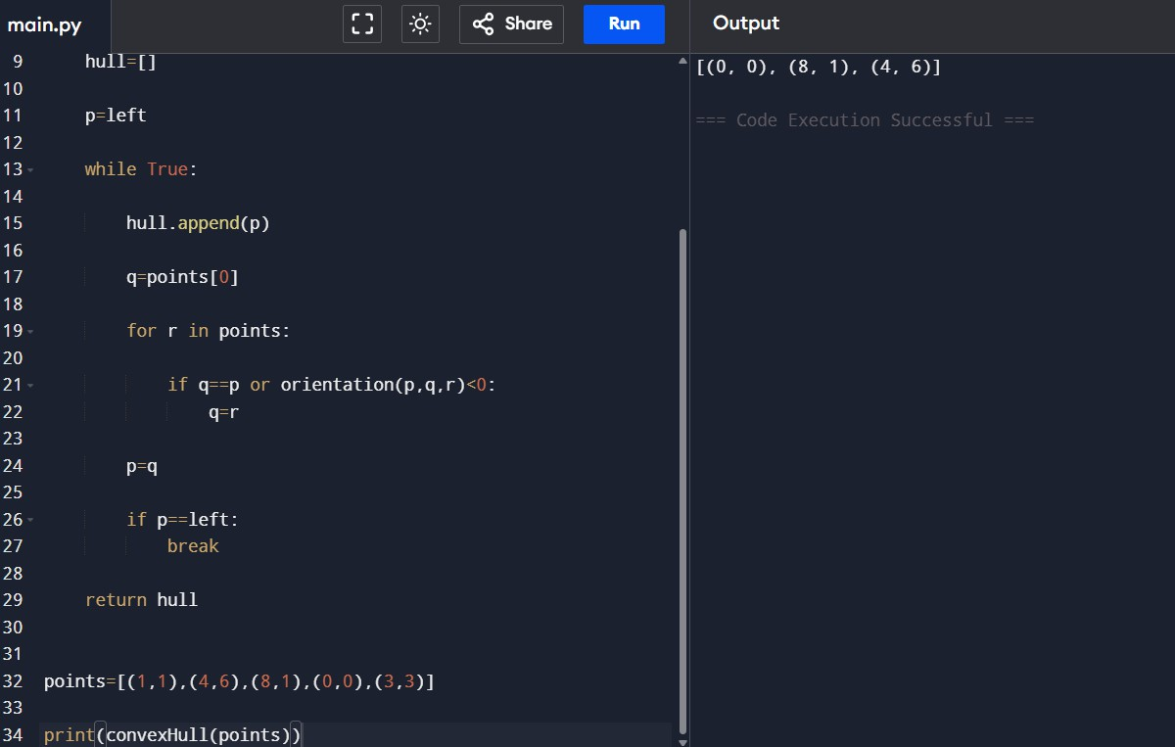
- 1 You are given a list of cities represented by their coordinates. Develop a program that utilizes exhaustive search to solve the TSP. The program should:
- Define a function distance(city1, city2) to calculate the distance between two cities (e.g., Euclidean distance).
- Implement a function tsp(cities) that takes a list of cities as input and performs the following:
  - Generate all possible permutations of the cities (excluding the starting city) using itertools.permutations.
  - For each permutation (representing a potential route):
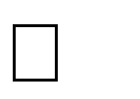

Calculate the total distance traveled by iterating through the path and summing the distances between consecutive cities.
Keep track of the shortest distance encountered and the corresponding path.

  - Return the minimum distance and the shortest path (including the starting city at the beginning and end).

- Include test cases with different city configurations to demonstrate the program&#39;s functionality. Print the shortest distance and the corresponding path for each test
case. CODE
from itertools import permutations from math import dist
def tsp(cities): start=cities[0] shortest=float('inf') best_path=[]
for perm in permutations(cities[1:]): path=[start]+list(perm)+[start] distance=0
for i in range(len(path)-1): distance+=dist(path[i],path[i+1])
if distance<shortest: shortest=distance best_path=path
return shortest,best_path cities=[(1,2),(4,5),(7,1),(3,6)]
d,p=tsp(cities) print("Shortest Distance:",d) print("Shortest Path:",p)

OUTPUT

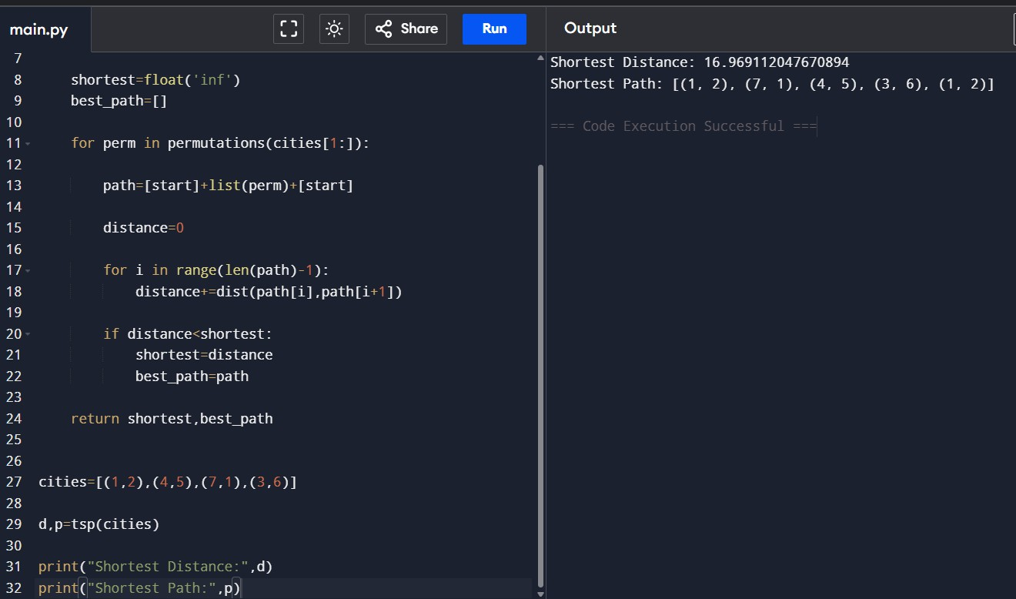
- You are given a cost matrix where each element cost[i][j] represents the cost of assigning worker i to task j. Develop a program that utilizes exhaustive search to solve the assignment problem. The program should Define a function total_cost(assignment, cost_matrix) that takes an assignment (list representing worker-task pairings) and the cost matrix as input. It iterates through the assignment and calculates the total cost by summing the corresponding costs from the cost matrix Implement a function assignment_problem(cost_matrix) that takes the cost matrix as input and performs the following Generate all possible permutations of worker indices (excluding repetitions). CODE
from itertools import permutations def assignment_problem(cost):
n=len(cost) minimum=float('inf') best=None
for perm in permutations(range(n)): total=0
for worker in range(n): total+=cost[worker][perm[worker]]

if total<minimum: minimum=total best=perm
return best,minimum cost=[[3,10,7],
[8,5,12],
[4,6,9]
assignment,total=assignment_problem(cost) print("Assignment:",assignment) print("Total Cost:",total)

OUTPUT
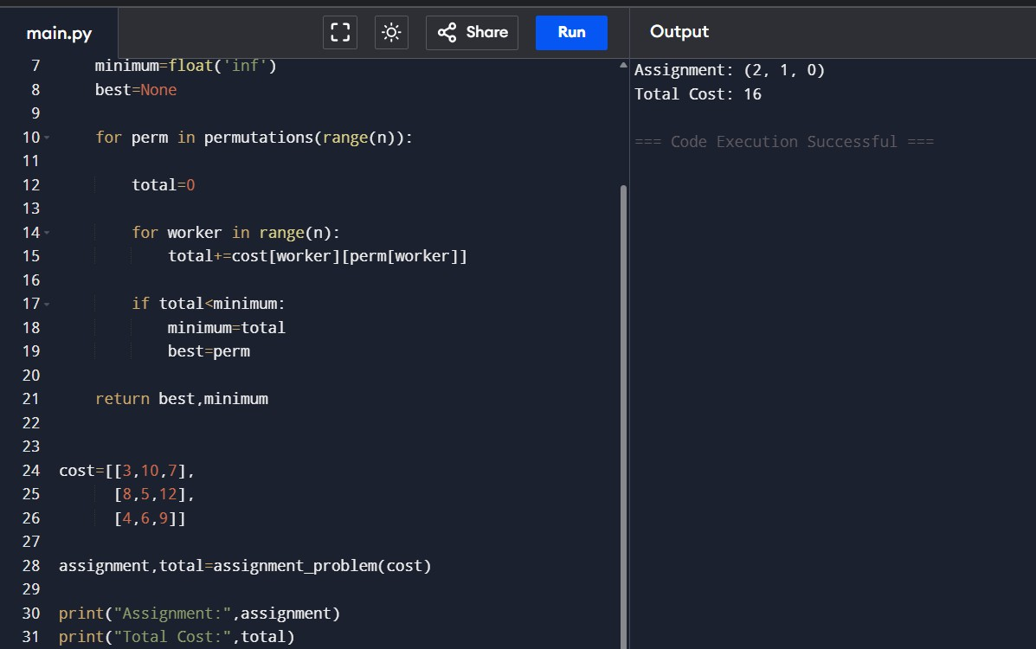

- You are given a list of items with their weights and values. Develop a program that utilizes exhaustive search to solve the 0-1 Knapsack Problem. The program should:
- Define a function total_value(items, values) that takes a list of selected items (represented by their indices) and the value list as input. It iterates through the selected items and calculates the total value by summing the corresponding values from the value list.

- Define a function is_feasible(items, weights, capacity) that takes a list of selected items (represented by their indices), the weight list, and the knapsack capacity as input. It checks if the total weight of the selected items exceeds the capacity. CODE
